Name : Hanas Bayu Pratama

Subject : Portfolio

The Post Below is My Portfolio

<https://epic-raman-69af4e.netlify.app/>

<http://kecapbetawi.epizy.com/index.php>

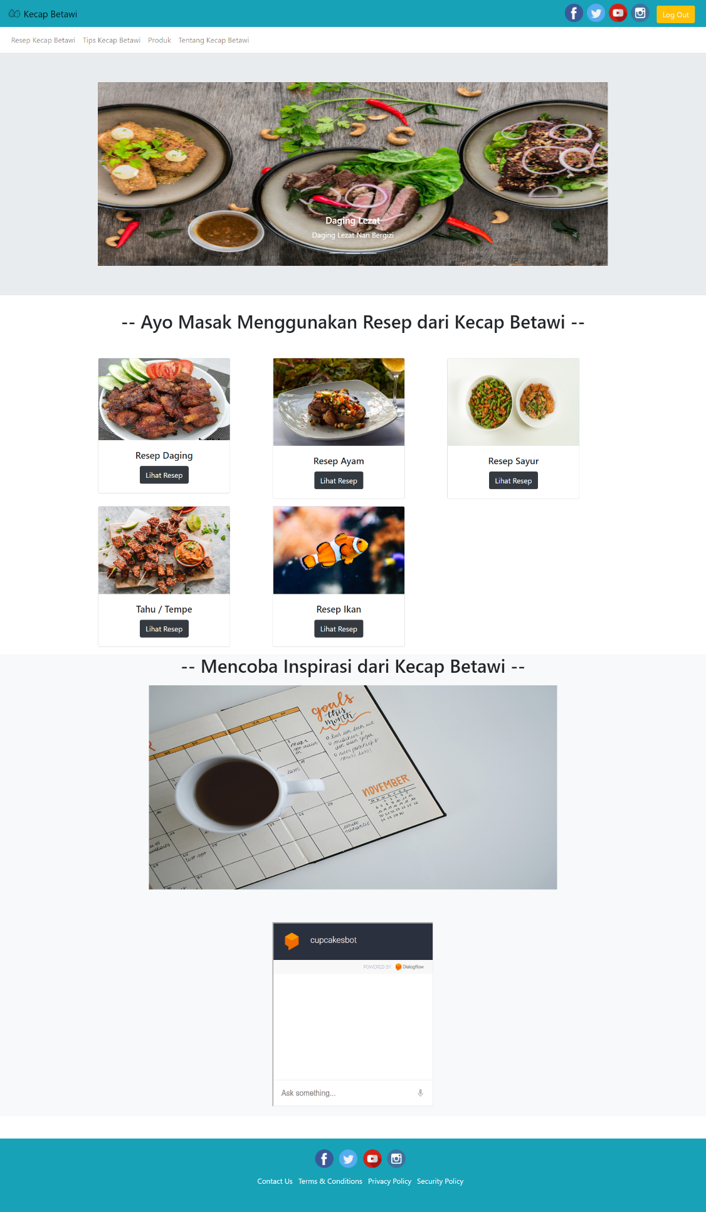

<https://brave-stonebraker-fc5e08.netlify.app/>

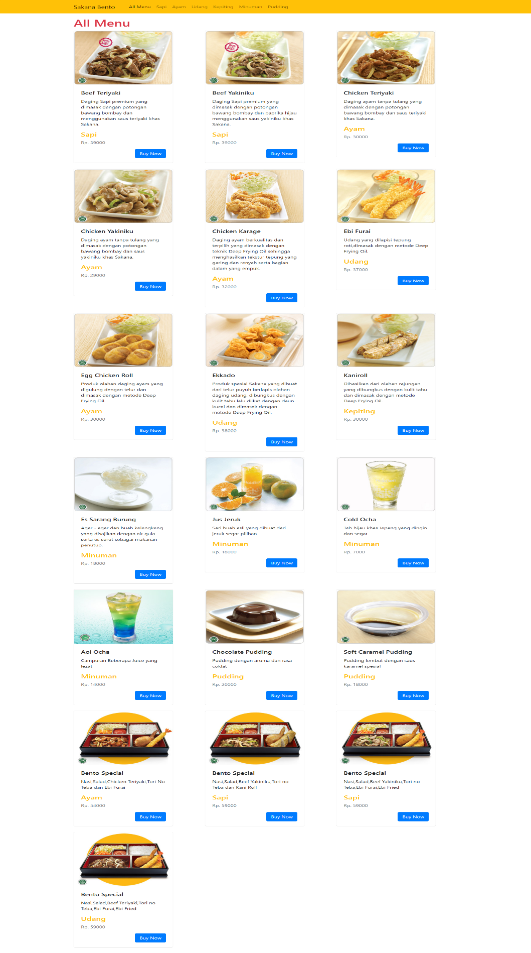<https://musing-leavitt-2b1a54.netlify.app/>

<https://musing-payne-31700b.netlify.app/>



<https://app.netlify.com/sites/dazzling-cray-b92544/overview>

